**ACE12448 | SURIYA VISHWA | Trainee, Impact Training**

**AZURE STORAGE ACCOUNT**

There are different types of storage services offered by Azure to store data.

**BLOB STORAGE:** It is used for unstructured data such as images, audio, video, and documents.

**FILE STORAGE:** File Storage in Azure is a fully managed, cloud-based file storage service that allows applications to access and store files using the standard Server Message Block (SMB) protocol.

**QUEUE STORAGE:** It provides afully managed cloud-based service for storing and retrieving large numbers of messages.

**STEPS TO CREATE STORAGE ACCOUNT**

1. Enter the azure portal <https://portal.azure.com> and search for the service storage account and click on it
2. In storage account you can see the option called Create storage account click it
3. Fill the mandatory project details like Resource group name, storage account name

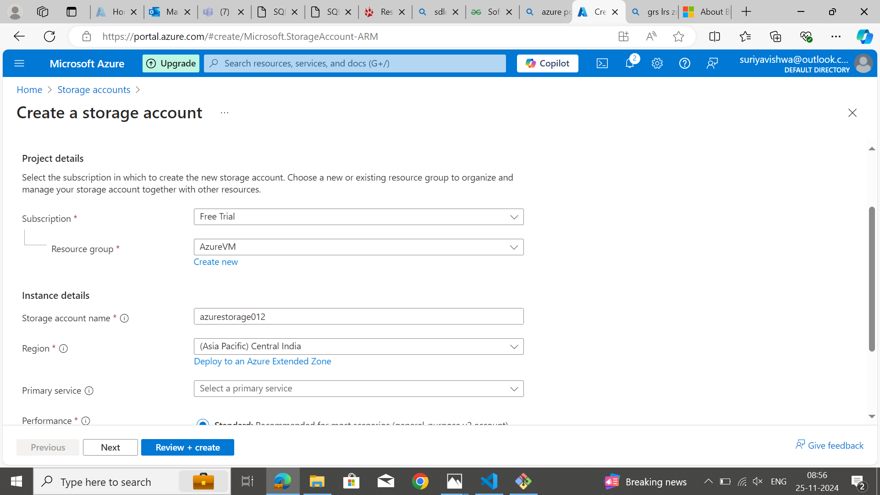

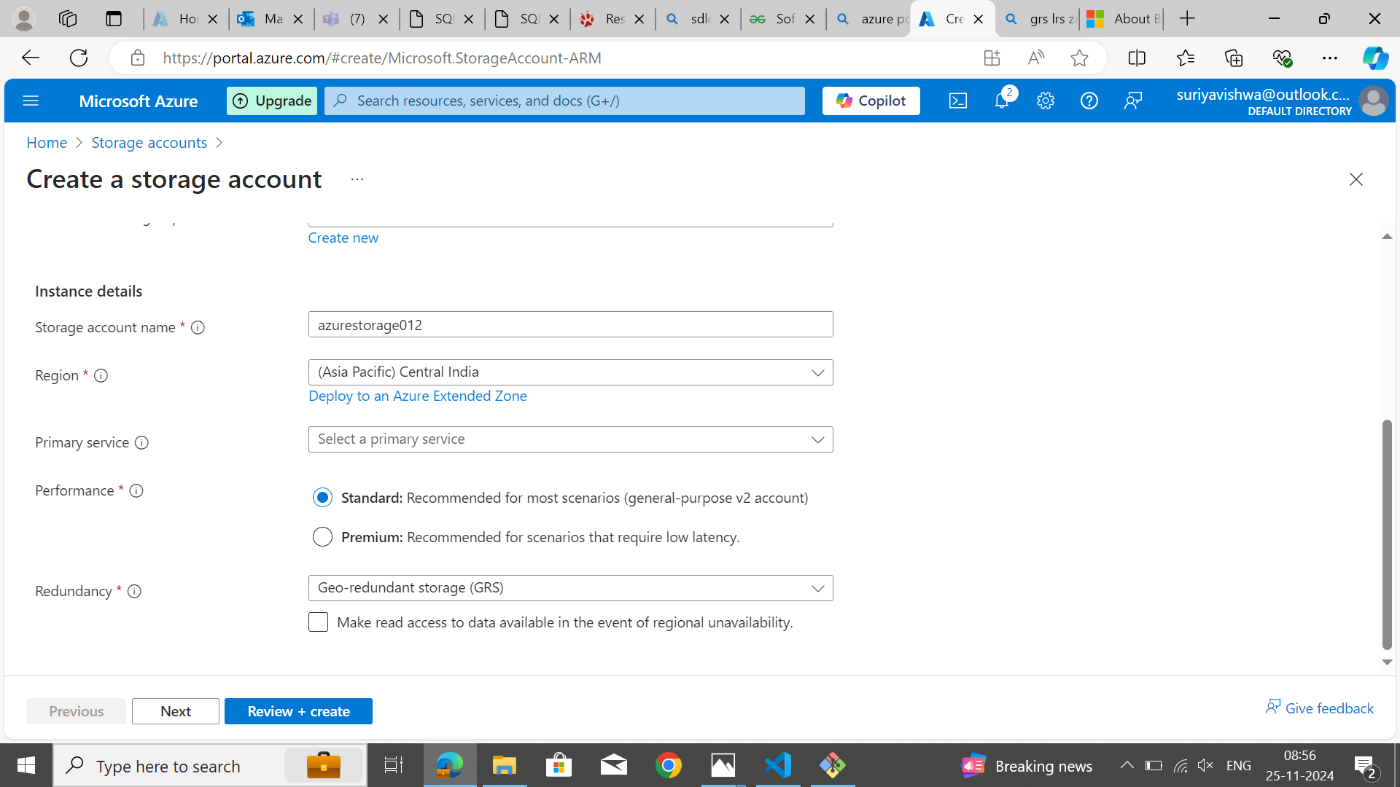

1. Fill in the security details, Access protocols, Tracking, Recovery and Encryption. Most details were set default since few options are paid.

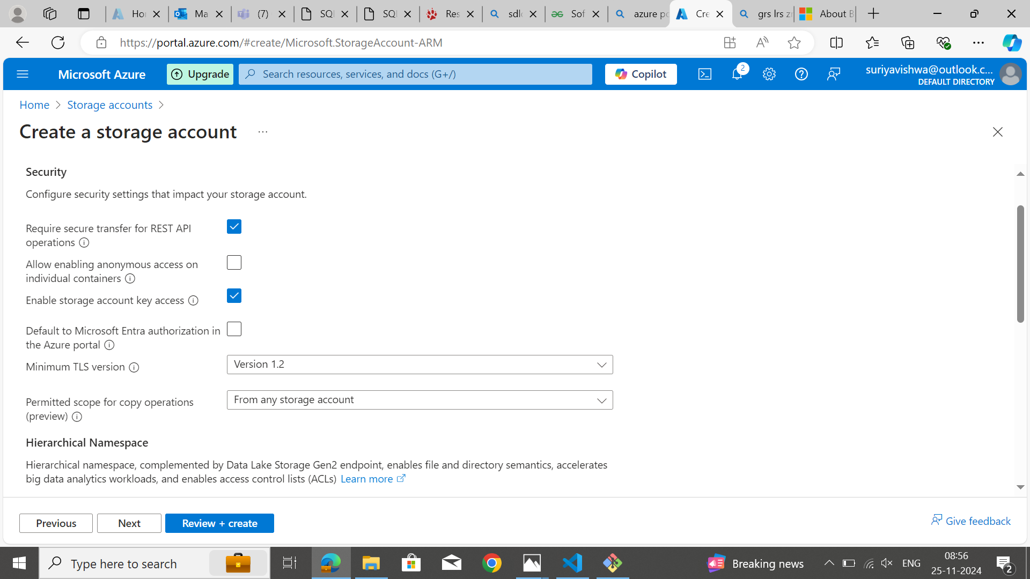

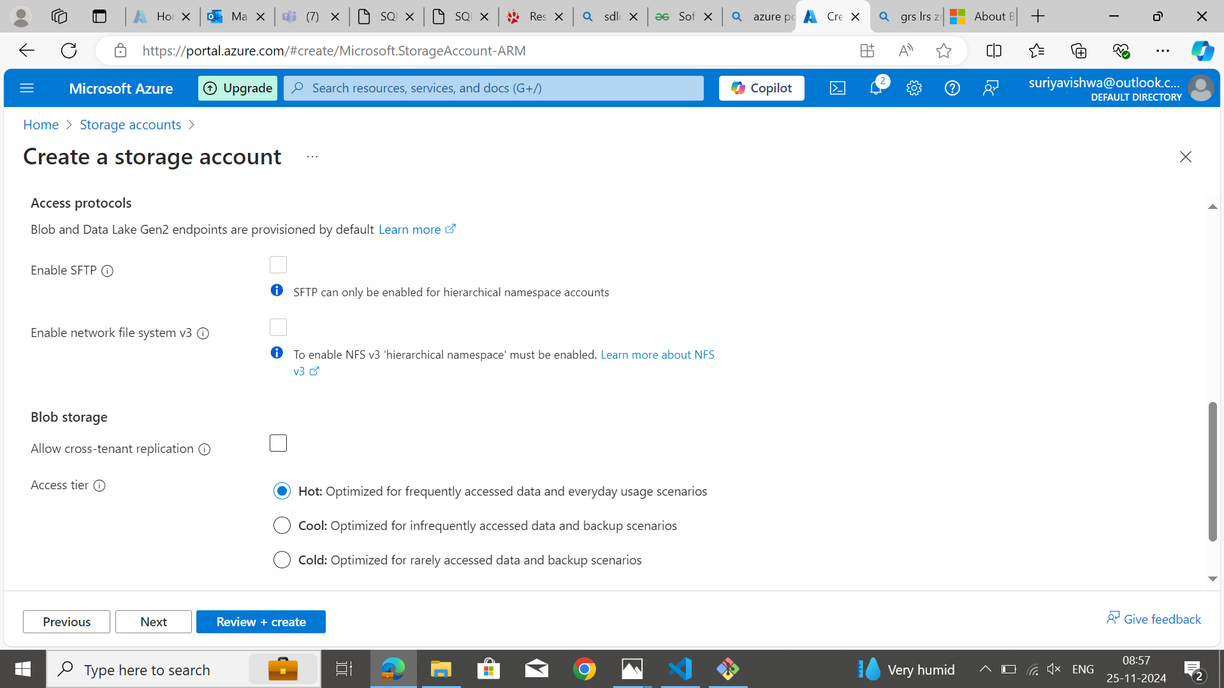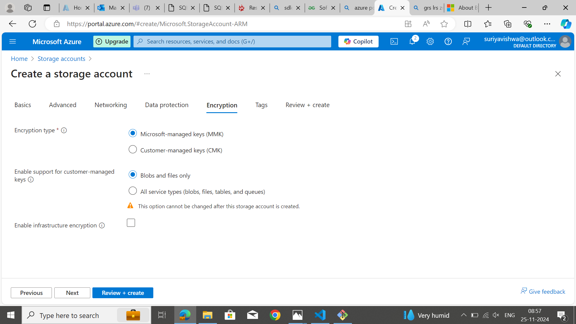

1. After filling in the details click on Review and create. Once you clicked create, the Deployment process will start. The properties of the storage account will be displayed after successful deployment.

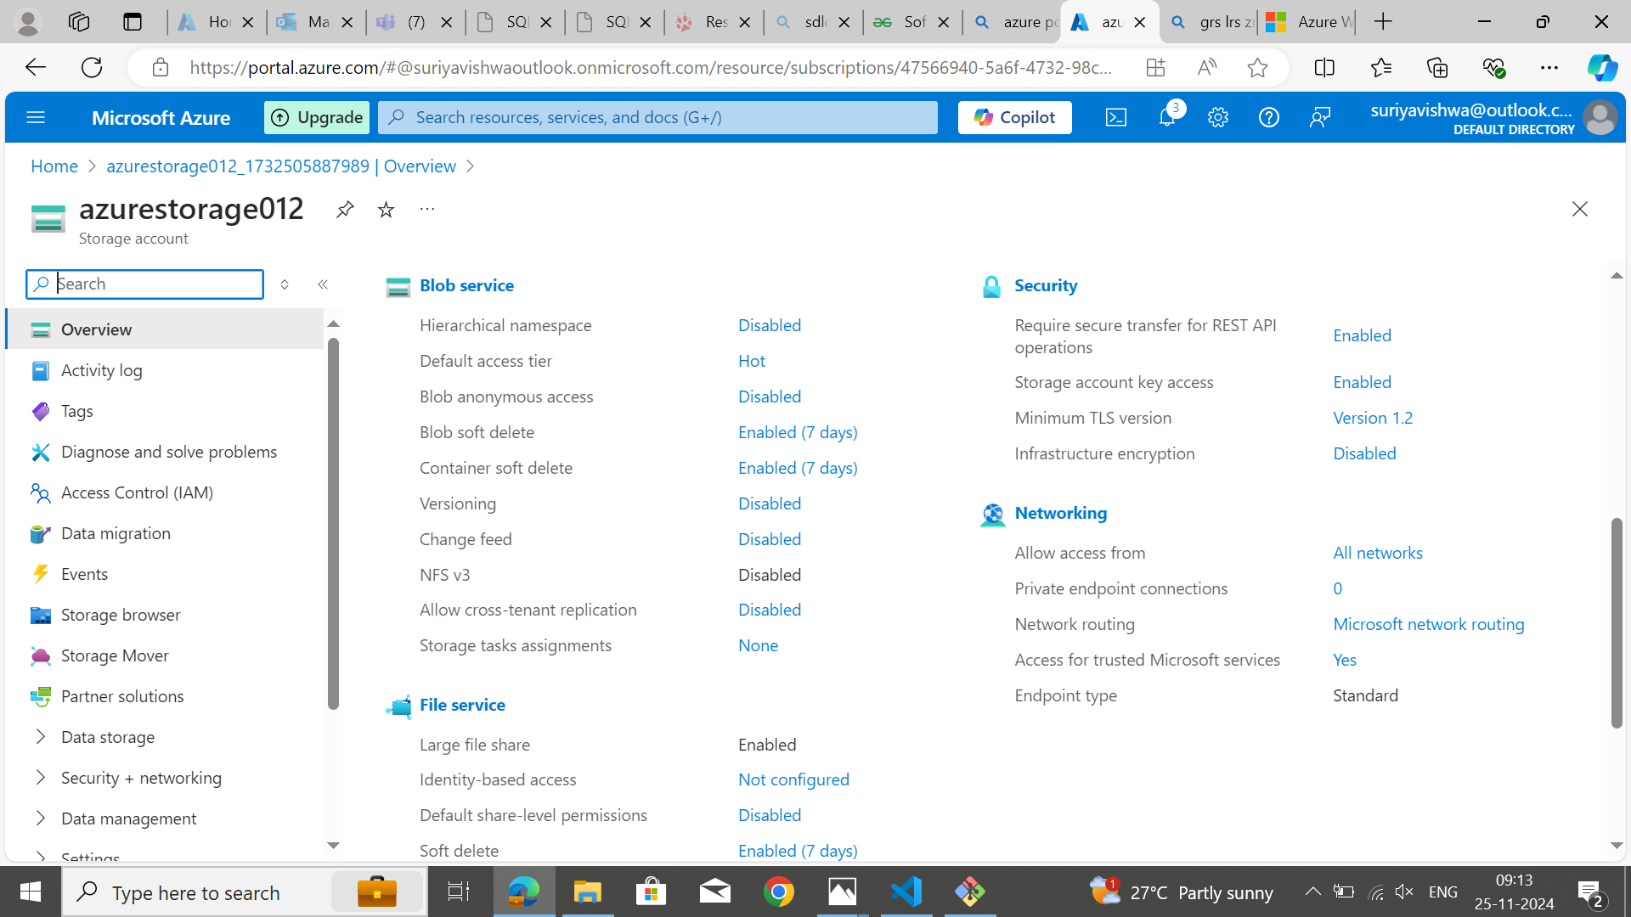

1. Click upload. Create a new container. Upload the files in it

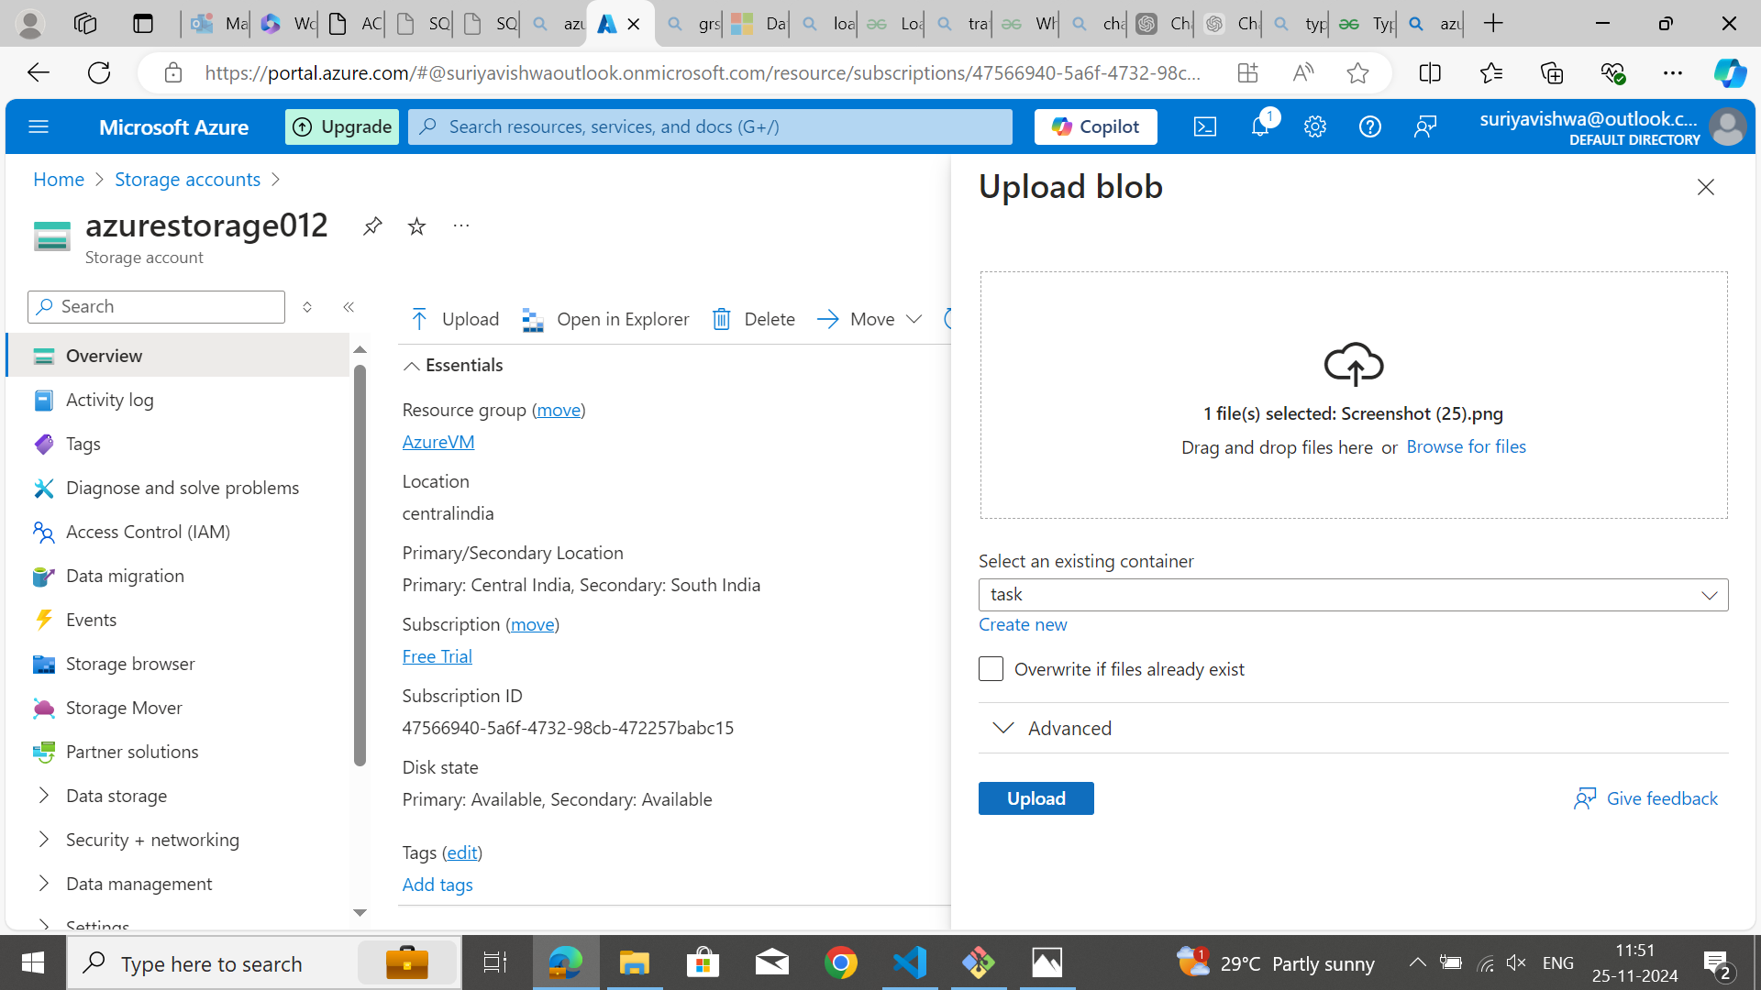

1. To view the uploaded files, go to Data storage and click containers. You can see the new container created. Click the container and you can view the uploaded file.

